DATE:
EXP NO: 9

Mini project - Social Media Engagement Dataset

AIM
To analyze and clean a Social Media Engagement Dataset using Python and Pandas, remove missing, invalid, and duplicate records, store the cleaned data in PostgreSQL/Supabase, and perform SQL-based engagement analysis for dashboard creation and business insights.

ALGORITHM

Install Required Libraries
- Install the required Python libraries for data processing and database connectivity.
- Use:
  - Pandas for data manipulation.
  - NumPy for numerical operations.
  - SQLAlchemy for PostgreSQL connectivity.
  - Psycopg2 for PostgreSQL database support.

Import Libraries
- Import Pandas and NumPy.
- Import SQLAlchemy functions for database connection.
- Import quote_plus() for secure password encoding.

Upload the Dataset
- Upload the file:
social_media_engagement_dataset(1).csv
- Store the uploaded file in Google Colab for processing.

Read the Dataset
- Read the dataset using Pandas.
- Store the dataset in a DataFrame named df.
- Display:
  - Dataset shape
  - First few records
- Verify that the dataset is loaded correctly.

Check the Dataset Before Cleaning
- Display all column names.
- Check data types of all fields.
- Identify missing values using:
isnull()
- Identify duplicate records using:
duplicated()
- Determine the required cleaning operations.

Clean the Social Media Dataset

Create Dataset Copy
- Create a copy named:
social_clean
to preserve the original dataset.

Clean Column Names
- Remove extra spaces.
- Convert column names to lowercase.
- Replace spaces with underscores.
Example:
Post Length → post_length
Engagement Rate → engagement_rate
- Remove rows where all values are missing.
- Identify and remove duplicate records.
Convert the following fields into numeric format:
- post_length
- views
- likes
- comments
- shares
- engagement_rate
Invalid values are converted to:
NaN
Check:
- post_length
- views
- likes
- comments
- shares
Replace negative values with:
NaN
because engagement metrics cannot be negative.
Replace missing numeric values using:
Median Value
This reduces the effect of outliers.
Clean text columns:
- platform
- post_type
Operations:
- Remove spaces
- Convert to lowercase
- Standardize values
Example:
Instagram → instagram
VIDEO → video

- Display:
  - Total rows
  - Missing values
  - Duplicate count
- Confirm:
Duplicates = 0
- Display sample records.

Save the cleaned dataset as:
social_media_engagement_cleaned.csv
without index values.

Define:
- Username
- Password
- Host
- Port
- Database
Create a PostgreSQL connection using SQLAlchemy.
Establish communication between Python and Supabase PostgreSQL.

Execute:
SELECT version();
Display PostgreSQL version information.
Verify successful connection.

Create a table named:
post_engagement
Upload the cleaned dataset using:
to_sql()
Use:
chunksize = 5000
for efficient storage.
Replace existing data if required.

Verify Stored Data
Execute:
SELECT COUNT(*) FROM post_engagement;
Verify that all records are stored successfully.
Compare database count with DataFrame count.

Perform SQL-Based Engagement Analysis
Calculate average engagement rate for each platform.
SQL Query:
SELECT
platform,
ROUND(AVG(engagement_rate), 4) AS avg_engagement
FROM post_engagement
GROUP BY platform
ORDER BY avg_engagement DESC;
Display:
- Platform
- Average Engagement Rate
Example Output:
Platform | Avg Engagement
instagram | 8.54
youtube | 7.92
facebook | 6.81
twitter | 5.46

Dashboard Preparation
Use PostgreSQL data in Power BI or Tableau.
Create visualizations such as:
- Total Views
- Total Likes
- Total Shares
- Average Engagement Rate
- Platform-wise Engagement
- Post Type Analysis
- Top Performing Platforms
- Engagement Trends

OUTPUT:
DATABASE:
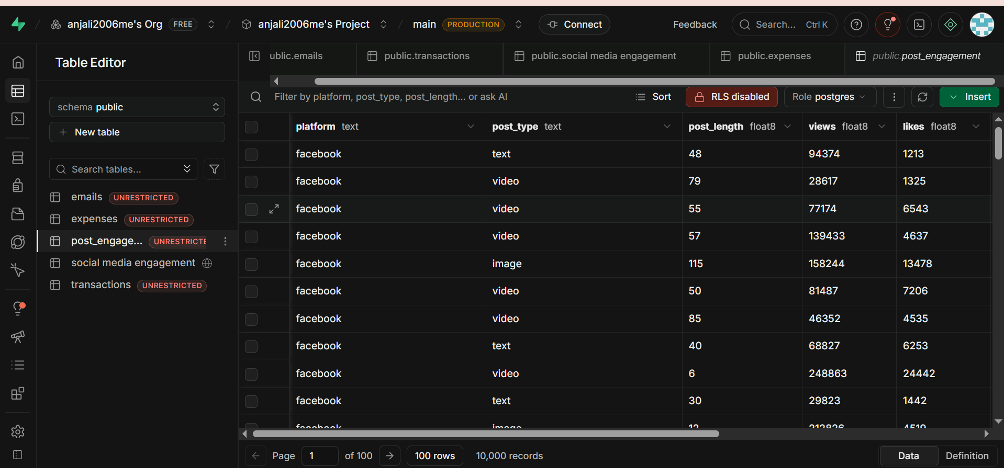

POWER BI:
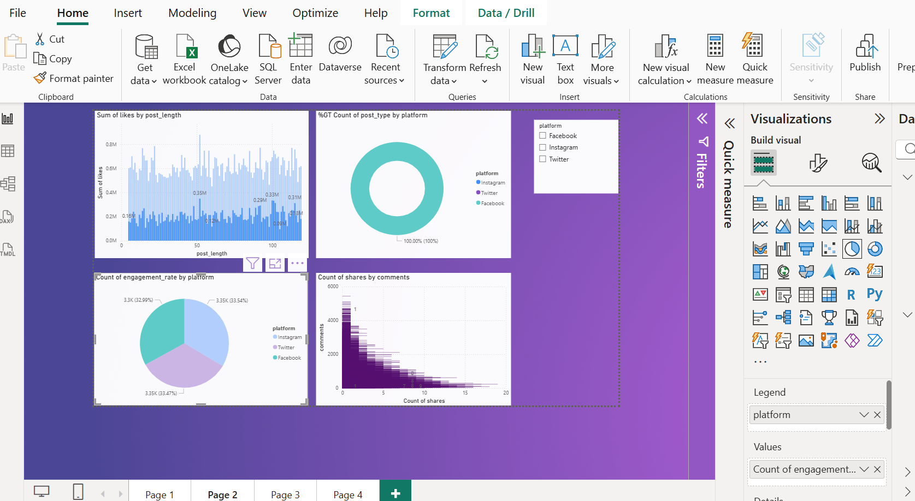

TABLEAU:
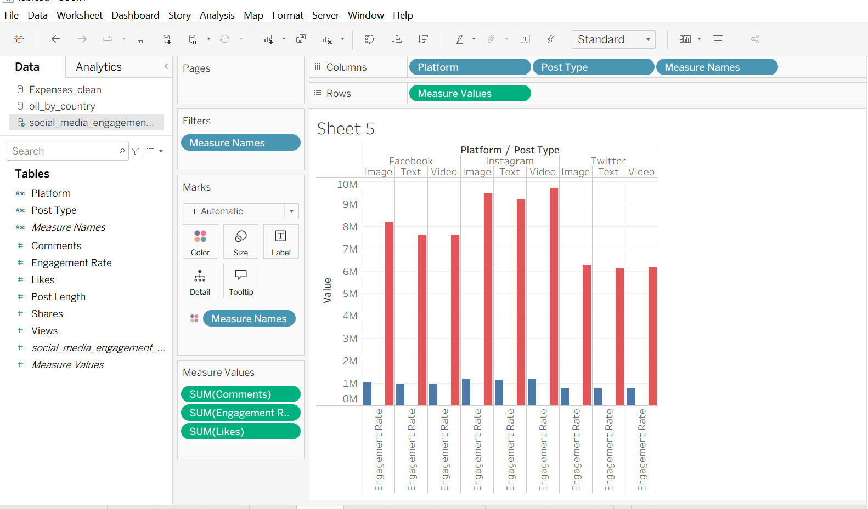

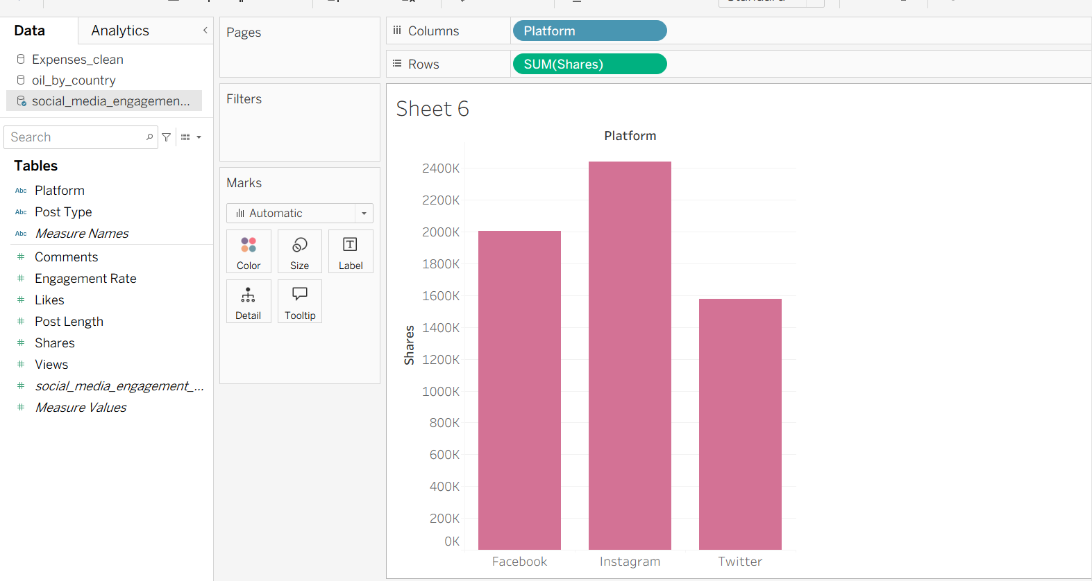

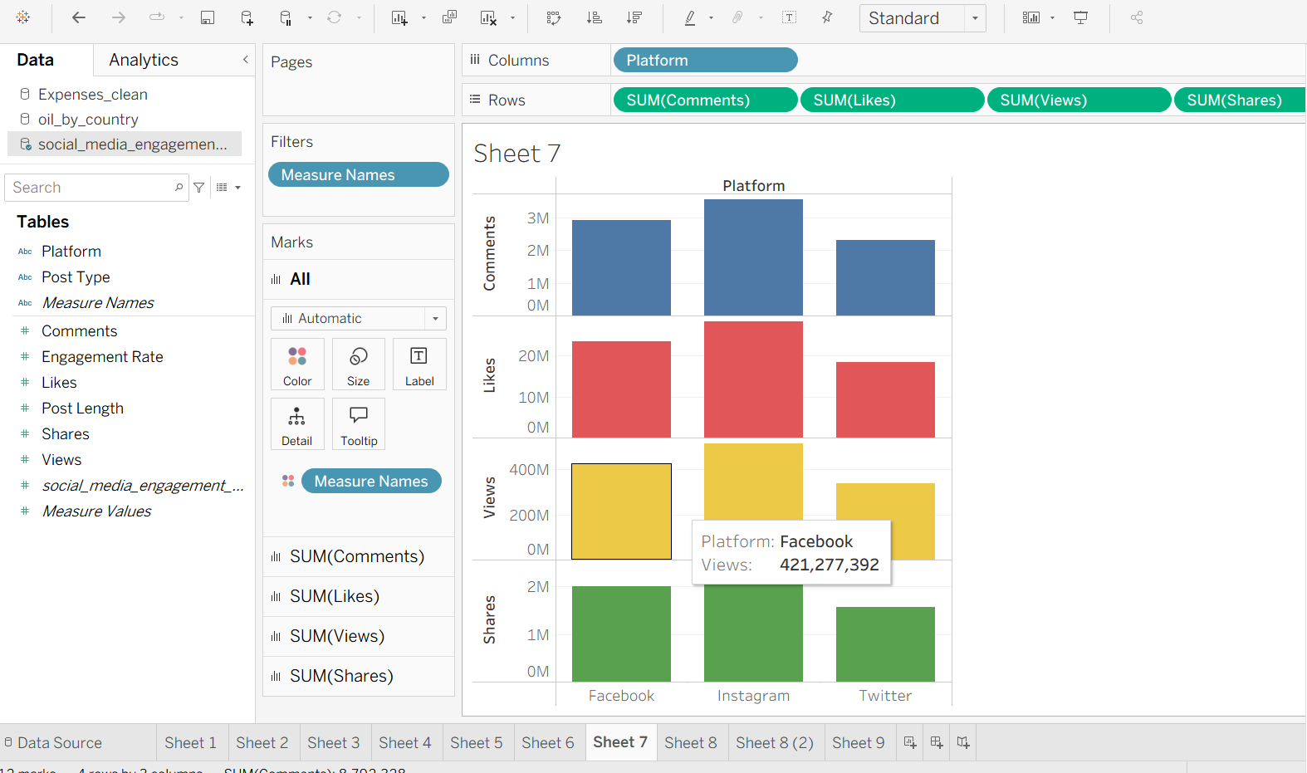
RESULT:

